R. Reports Menu: H. Comment File Report

This allows you to preview/print/save a report which shows every Comment Code and its related comment for this module.

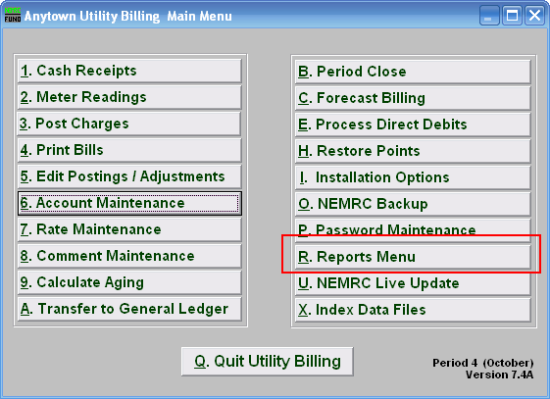
Click on “R. Reports Menu” from the Main Menu and the following window will appear:

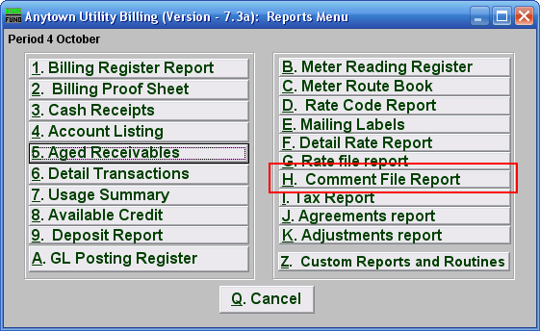
Click on “H. Comment File Report” from the Reports Menu and the following window will appear:

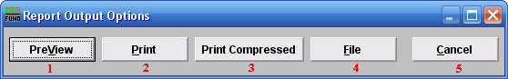
- PreView: Click this button to preview the Comment Code report. You may also print from the preview screen. For more information on previewing, refer to GENERAL PREVIEW.

- Print: Click this button to print the Comment Code report. You may also print from the preview screen. For more information on printing, refer to GENERAL PRINT.

- Print Compressed: Click this button to print the Comment Code report. This is different from the “Print” option in that it will use less paper for the same report.

- File: Click this button to save the Comment Code report to this workstation. For more information on saving reports, refer to GENERAL FILE.

  - Cancel: Click “Cancel” to return to the Reports Menu window.

